Graph coloring and types:-

In graph theory, graph coloring is a special case of graph labeling; it is an assignment of labels traditionally called "colors" to elements of a graph subject to certain constraints.

In its simplest form, it is a way of coloring the vertices of a graph such that no two adjacent vertices are of the same color; this is called a vertex coloring.

Similarly, an edge coloring assigns a color to each edge so that no two adjacent edges are of the same color, and a face coloring of a planar graph assigns a color to each face or region so that no two faces that share a boundary have the same color.

Vertex coloring is the starting point of graph coloring. Other coloring problems can be transformed into a vertex version.
History:-
While trying to color a map of the counties of England, in 1852 Francis Guthrie postulated the four color conjecture, noting that four colors were sufficient to color the map so that no regions sharing a common border received the same color.
In 1879, Alfred Kempe published a paper that claimed to establish the result (4 color).
In 1890, Heawood pointed out that Kempe’s argument was wrong. However, in that paper he proved the five color theorem, saying that every planar map can be colored with no more than five colors, using ideas of Kempe.
In the following century, a vast amount of work and theories were developed to reduce the number of colors to four, until the four color theorem was finally proved in 1976 by Kenneth Appel and Wolfgang Haken.
In 1912, George David Birkhoff introduced the chromatic polynomial to study the coloring problems.
It was established as the celebrated strong perfect graph theorem by Chudnovsky, Robertson, Seymour, and Thomas in 2002.
Some important Terms:-
A coloring using at most k colors is called a (proper) k-coloring.
The smallest number of colors needed to color a graph G is called its chromatic number.
The chromatic polynomial counts the number of ways a graph can be colored using no more than a given number of colors. For example, using three colors, the graph in the adjacent image can be colored in 12 ways. With only two colors, it cannot be colored at all. With four colors, it can be colored in 24+4⋅12=72 ways: using all four colors, there are 4!=24 valid colorings (every assignment of four colors to any 4-vertex graph is a proper coloring); and for every choice of three of the four colors, there are 12 valid 3-colorings. So, for the graph in the example, a table of the number of valid colorings would start like this:
Available colors | 1 | 2 | 3 | 4 | …
Number of colorings | 0 | 0 | 12 | 72 | …
The chromatic polynomial is a function P(G,t) that counts the number of t-colorings of G. As the name indicates, for a given G the function is indeed a polynomial in t. For the example graph, P(G,t)=t(t−1)2(t−2), and indeed P(G,4)=72.
Algorithms:-
Unfortunately, there is no efficient algorithm available for coloring a graph with minimum number of colors as the problem is a known NP Complete problem. There are approximate algorithms to solve the problem though. Following is the basic Greedy Algorithm to assign colors. It doesn’t guarantee to use minimum colors, but it guarantees an upper bound on the number of colors. The basic algorithm never uses more than d+1 colors where d is the maximum degree of a vertex in the given graph.
NP is set of decision problems that can be solved by a Non-deterministic Turing Machine in Polynomial time.
NP-complete problems are the hardest problems in NP set. A decision problem L is NP-complete :
1) L is in NP (Any given solution for NP-complete problems can be verified quickly, but there is no efficient known solution).
2) Every problem in NP is reducible to L in polynomial time (Reduction is defined below).
Basic Greedy Coloring Algorithm:-

1. Color first vertex with first color.
2. Do following for remaining V-1 vertices.
a) Consider the currently picked vertex and color it with the lowest numbered color that has not been used on any previously colored vertices adjacent to it.
b) If all previously used colors appear on vertices adjacent to v, assign a new color to it.
3. Repeat step 2 until all vertices are colored and stop.

Heuristics used :-

The quality of the resulting coloring depends on the chosen ordering.
If the vertices are ordered according to their degrees, the resulting greedy coloring uses at most colors, at most one more than the graph’s maximum degree. Called the Welsh–Powell algorithm.
Another heuristic due to Brélaz establishes the ordering dynamically while the algorithm proceeds, choosing next the vertex adjacent to the largest number of different colors.
These algorithm are called sequential coloring algorithms.
Applications :-
Register Allocation,Scheduling,Sudoku,Map Coloring,Checking a graph is bipartite or not.
Understanding Register Allocation :-
Register allocation is the process of determining which values should be placed into which registers and at what times during the execution of the program.
There will always be some pieces of code that require more registers than actually exist. In such cases, the register allocator must insert spill code to store some values back into memory for part of their lifetime.
Minimizing the runtime cost of spill code is a crucial consideration in register allocation.
This is done by the compiler.

History :-

Register allocation shows close correspondence to the mathematical problem of graph coloring. The recognition of this correspondence is originally due to John Cocke, who first proposed this approach as far back as 1971. Almost a decade later, it was first implemented by G. J. Chaitin and his colleagues in the PL.8 compiler for IBM's 801 RISC prototype.
Formulation :-
Each node in the graph represents the live range of a particular value.
A live range is defined as a write to a register followed by all the uses of that register until the next write.
An edge between two nodes indicates that those two live ranges interfere with each other because their lifetimes overlap.
The resulting graph is thus called an interference graph.
The register allocation problem becomes equivalent to coloring the graph using as few colors (registers) as possible.
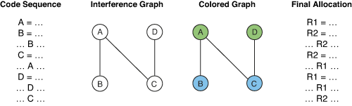

Given an interference graph, the register allocation problem becomes equivalent to coloring the graph using as few colors (registers) as possible, and no more than the total number provided by the target architecture.

Steps :-

First, the live ranges must be determined. This is not as trivial as it seems

Constructing the interference graph is the next step. Usually, the graph is created in two forms simultaneously – a bit matrix and a set of adjacency lists. This makes working with the graph more efficient, allowing quick tests for the existence of an edge using the bit matrix and quick calculation of the set of neighbors which interfere with any particular node by examining the adjacency lists.

After building the graph, unneeded copies (register-to-register move instructions) are eliminated in the coalesce phase. This might sound unnecessary, but it is actually an extremely important step, partially because copies are often introduced during optimization,

After coalescing, the whole graph must then be rebuilt because eliminating the copies might have changed the interference relationships.

Once the graph is constructed, spill costs are calculated for each node (live range) using a variety of heuristics to estimate the runtime cost of storing each value and reloading it around its uses.

The core of the coloring process itself starts with the simplify phase, sometimes called pruning. Here, the graph is repeatedly examined and nodes with fewer than k neighbors are removed (where k is the number of colors we have to offer). As each node is removed it is placed on a stack and its edges are removed from the graph, thereby decreasing the degree of interference of its neighbors. If a point is reached where every node has k neighbors (or more), a node is chosen as a possible spill candidate.
Once a spill candidate is chosen, the node is then removed from the graph and pushed onto the stack, just like the others, and the algorithm continues on to the next node.

Finally, the select phase actually selects a color (register) for each node. This is done by repeatedly popping a node off the stack, re-inserting it into the graph, and assigning it a color different from all of its neighbors. In effect, simplify chooses the order of assignment and select makes the actual assignments themselves.

At any time during the select phase, if a situation occurs where no color is available (ie: all k neighbors have different colors), the node is marked for spilling and remains uncolored while the algorithm continues on to the next node. If nodes have been left uncolored after this process, the allocator must then generate the necessary spill code (or rematerialization code) and start the whole register allocation process all over again.

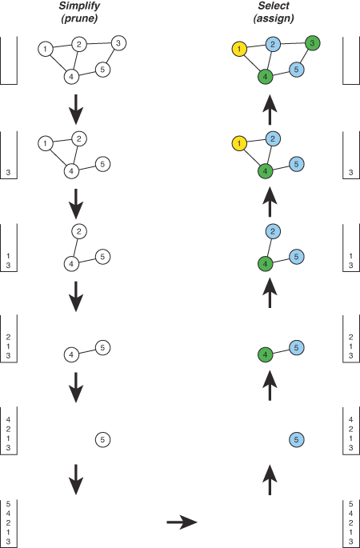

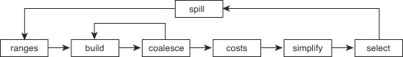

Scheduling :-

The general idea of a scheduling problem is defined by allocation of related resources
among a number of time-slots satisfying various types of essential and preferential
constraints aiming at creating optimized conflict-free schedule.

Some of the typical scheduling problems include-
•Timetable Scheduling
a.Course Timetable Scheduling- courses sharing common resources to be
scheduled in conflict-free time-slots.
b.Exam Timetable Scheduling – exams sharing common resources to be
scheduled in conflict-free time-slots.
•Aircraft Scheduling- aircrafts need to be assigned to flights.
•Job Shop Scheduling- for a given set of jobs with their processing times and a
given set of machines, a schedule mapping jobs to machines meeting feasibility
constraints and optimization objectives.

Course Timetabling is the scheduling of a set of related courses in a minimal number
of time-slots such that no resource is required simultaneously by more than one event.
In a typical educational institute resources, which may be required by courses
simultaneously can be students, classrooms and teachers.

Constraints :-

No two subjects having common students can be scheduled in the same time-slot, courses cannot be assigned to more than maximum number of available time-slots or periods. In those scheduling datasets which involve resources like teachers and classrooms, no courses can be scheduled to
the same classroom at same time-slot, more than one course taught by the same
teacher cannot be assigned same time of the week.

Formulation :-

For solving Course Timetable scheduling problems using graph coloring, the problem is first formulated in the form of a graph where courses act as vertices.
Depending on type of graph created, edges are drawn accordingly.
Edges are drawn between conflicting courses having common students, common teachers, common classrooms, etc.
Example

Problem : Given n number of honours subjects and m number of general subjects, the available number of p periods course timetable should be prepared satisfying some given constraints.
Objective : Find minimum number of time slots to schedule all the courses without conflict.
List of constraints :
• Courses having common student cannot be allotted at the same time slot onthe same day.
• Total number of available periods is 8.

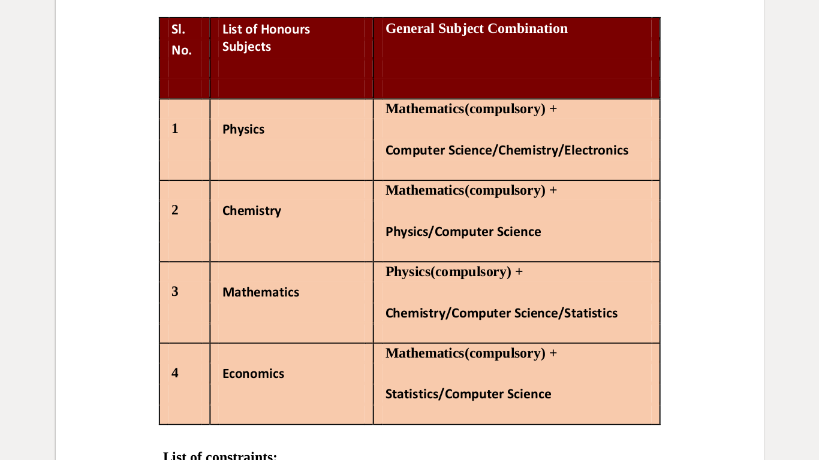
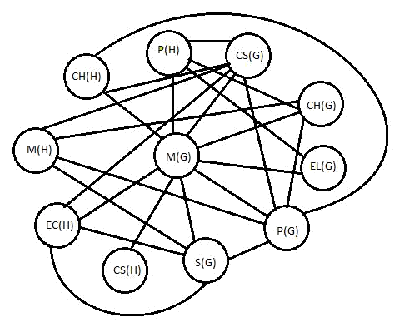

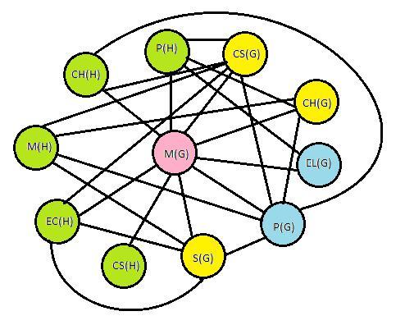

Solution:
Considering each course as a node, edge between two nodes is drawn only if there is
common student. (See Fig. 3)
Fig. 3 Course Conflict Graph
N.B. (H) and (G) notations represent Honours and General courses respectively.
CH- Chemistry, M- Mathematics, EC-Economics, CS-Computer Science, P-Physics,
S-Statistics, EL-Electronics.
After applying graph coloring algorithm, the resultant graph in Fig. 4 is properly
colored with chromatic number 4. This is the minimum number of non-conflicting
time-slots scheduling all the given courses.

Result:
In the above solution, the hard constraints are satisfied properly. The resultant
minimum number of time slots needed is 4 which do not exceed the total available 8
periods. All the Honours subjects cannot have common student, hence allotted in slot-
1. Similarly, no student overlapping is possible between Electronics and Physics
General, or students between Chemistry, Computer Science and Statistics General.
Mathematics(General) being compulsory for all Honours subject except Mathematics
itself, is given separate slot 2. But since there can never be common students in
Mathematics(H) and Mathematics(G), alternative solutions exist. Similarly, there can
be other legal combinations as well.

Sudoku: -

Sudoku is one of the most interested number placement-puzzle and it is also a variation of Graph-coloring problem.
Where, every cell represents a vertex. There is an edge between two vertices if they are in same row or same column or same block.

